Notes from March 18th session Meetings That Rock
PARTICIPANT EXPECTATIONS:
By the end of this training I hope to be able to:
• Provide structure (aka getting through agenda as promised)....while allowing for (encouraging) free-flow, things to emerge, and readjust an agenda if wise to do so.
• Organize my self-designed workshops, sessions and trainings with more clarity and specificity.
• Have certain phrases or language that help me move meetings forward while honoring everyone's participation and different needs.
• Feel more confident when I facilitate and be seen as confident, knowledgeable, authentic, welcoming and inclusive.
• Be more professional as a facilitator. Able to design a robust facilitation flow which can enhance the dialogue among the participants
• Utilise a broader range of approaches in my facilitation
Welcome:
What is your organization? What is your interest in leading meetings? Where are you from?
Molly Shaw: I'm from Seattle. My organization is Facilitators Northwest - I am a sole proprietor of a woman-owned business, doing facilitation and training. I am the new president of a nonprofit foundation, and I am always interested in getting better at leading meetings so that others feel fully engaged and find meetings worth their time; and so they want to come back for more!
Teresa Lingafelter: I live in Portland and am interested in helping strategic planning clients get the skills to follow through with implementation.
Nadine Bell: I am in Dallas, Texas, My organization is Prismatic Solutions. We help our clients solve intractable organizational and interpersonal challenges through face to face and virtual facilitation
Cheri Gurse: I'm an independent consultant and also a professor (Argosy University online faculty). As a consultant and educator, I do trainings, workshops, and classes in matters of social justice, diversity, etc.
What pages form handout intrigued you or made you want to dig in further?
Cheri Gurse: Exercises 8, 10, 14...
Molly Shaw: P. 8. 10, 21, 25, 37
Nadine Bell: Multiple Intelligences
Nadine Bell: pp 10-12

Questions I have about meetings:
Teresa Lingafelter: Getting quick consensus on the agenda.
Cheri Gurse: How can I help someone else who isn't facilitating well?
Nadine Bell: How do you engage participants who clearly do not want to be there.
Molly Shaw: What are the top 5 things I should remember to provide maximum participation?
Cheri Gurse: Big ditto to Nadine's question
Molly Shaw: What to do with participants who want to dominate the meeting calling attention to themselves?
Cheri Gurse: What to do when I can tell I'm losing the group or the agenda?
Flow Game:
Three things I really like about a great meeting:
Barbara Mackay: 3 things I really liked about a great meeting
Teresa Lingafelter: group is in-sync
Cheri Gurse: No or very little side-talking.
Molly Shaw: Meeting starts on time and ends on time, as arranged ahead of time.
Teresa Lingafelter: group is happy with the outcome
Teresa Lingafelter: group is proud of themselves
Barbara Mackay: I know exactly what we will be doing in the meeting
Cheri Gurse: Different styles, methods of presenting info and discussing.
Molly Shaw: Participants go out motivated and feel it was worth their time.
Cheri Gurse: On time start and finish.
Nadine Bell: 1. It has a purpose that is clear 2. It has an agenda that is designed to achieve the purpose and is followed. 3. The person running the meeting is effective
Molly Shaw: Participants have information they will apply
What is happening in a meeting I like?
Teresa Lingafelter: it has a good pace -- time to think, but not too much.
Barbara Mackay: it feels focused and purposeful but people are relaxed and laughing when appropriate
Teresa Lingafelter: Affirmation from the facilitator
Teresa Lingafelter: some humor
Cheri Gurse: It FEELS good...all present feel included, welcomed. No one feels shut down.
Teresa Lingafelter: productivity
Cheri Gurse: Some humor.
Molly Shaw: Participants are engaged and fully present
Cheri Gurse: Instructions are clear.
Cheri Gurse: Participants are affirmed authentically.

What do I feel when this happens in meetings?
Barbara Mackay: I feel happy, content, energized
Teresa Lingafelter: anxious to get to work with my team
Teresa Lingafelter: confident
Teresa Lingafelter: Honored and appreciated
Cheri Gurse: I feel like I've contributed.
Molly Shaw: appreciated
Cheri Gurse: Confident, energized, and pleased.
Nadine Bell: Grateful, satisfied
What is most important/satisfying about what is happening?
Barbara Mackay: I have contributed where I can and learn from others about what is happening in their thinking
Nadine Bell: People are engaged and fee they are heard.
Cheri Gurse: Participants are engaged.
Molly Shaw: People feel their time was well used. They have learned something they can apply or act upon
Teresa Lingafelter: the road is open to move ahead
Common themes amongst what we like about meetings
Cheri Gurse: Time...
Cheri Gurse: Being on time, and worth their time
Cheri Gurse: Clear purpose
Molly Shaw: Good feelings all around

What does this suggest we do differently?
Nadine Bell: Know and use the IAF competencies.
Cheri Gurse: Pay good attention to process, affect, feelings
Molly Shaw: Have a clear agenda posted
Teresa Lingafelter: Be as aware of what's happening to the group as we are what's happing with the content

Roles of the Facilitator:

Polls on which roles you feel you do well….

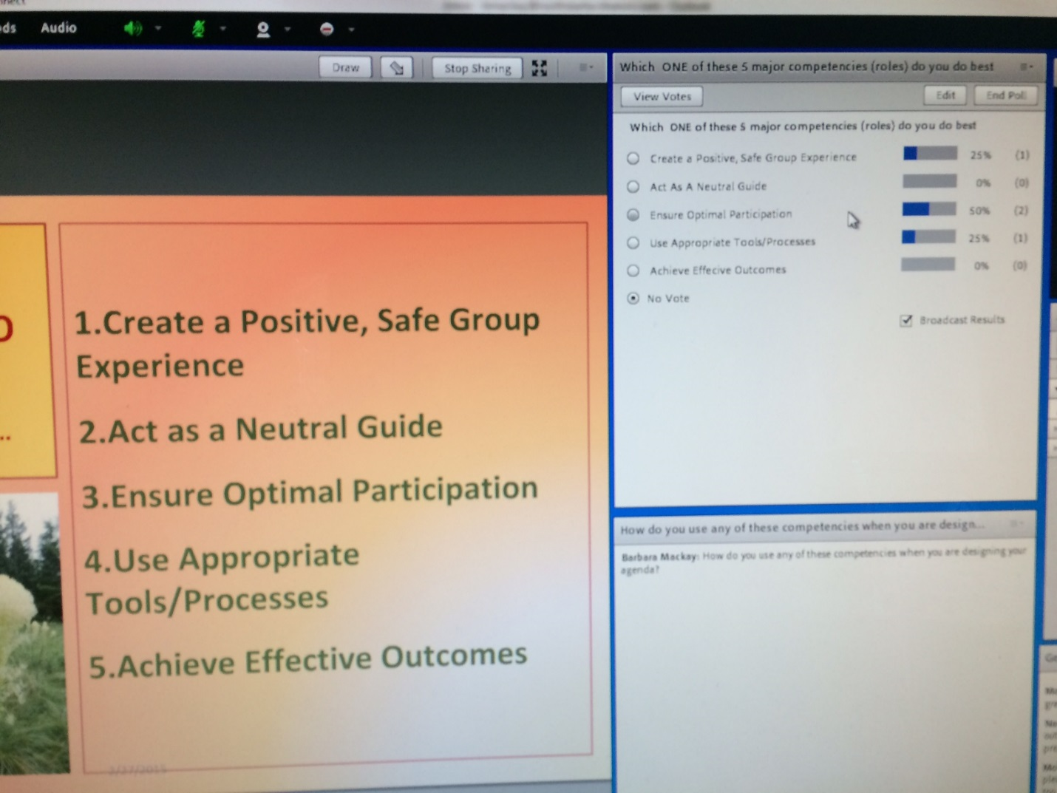

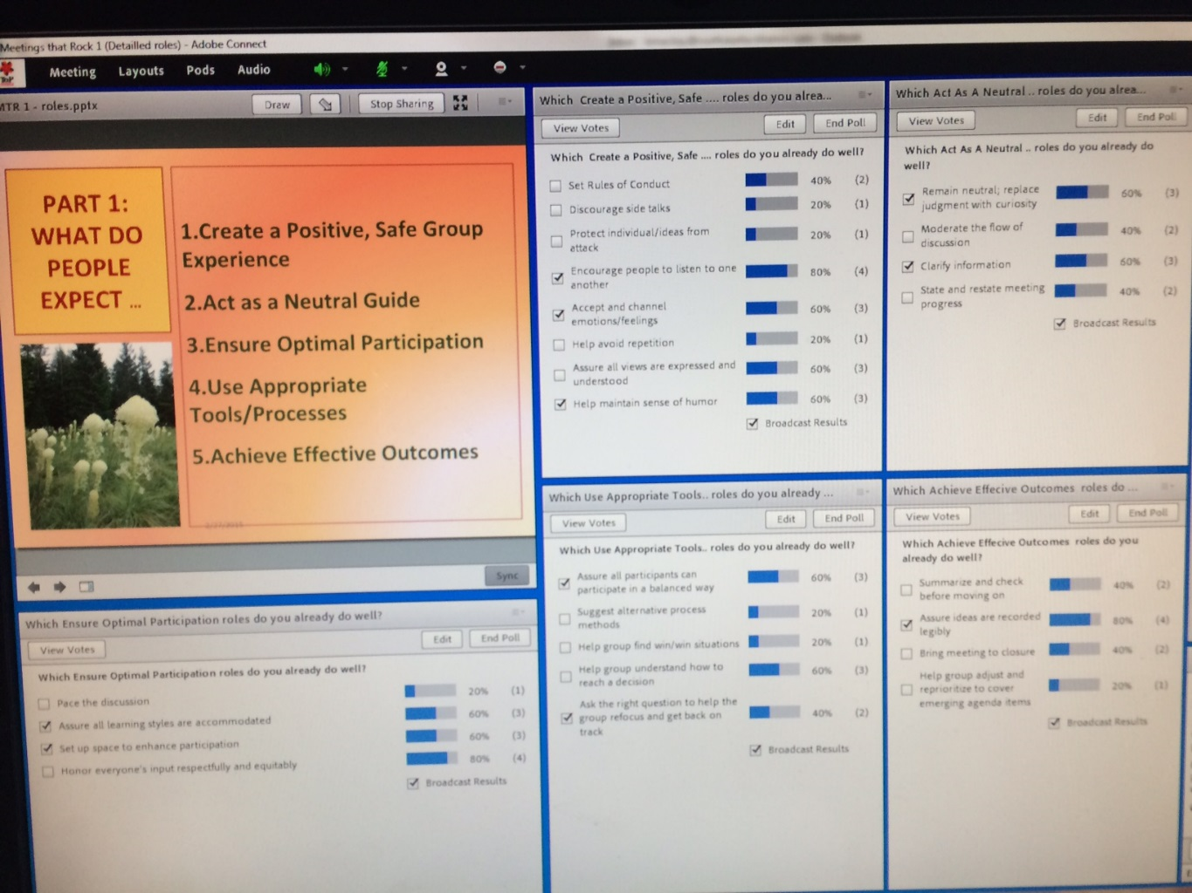

Multiple Intelligences
Polls on which intelligences you had 60% + on… top ones for this group were intrapersonal and interpersonal!
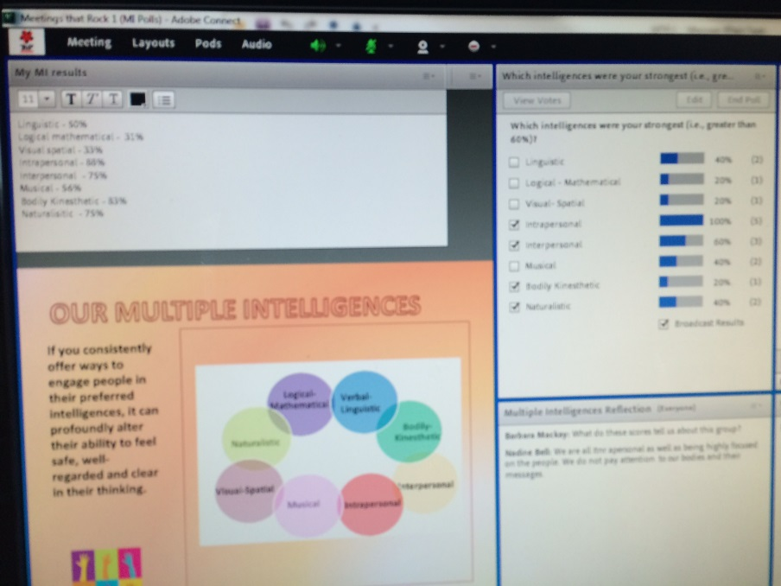
Based on what you know now – how can you accommodate the various intelligences?
Teresa Lingafelter: I’m not sure I know enough about the different intelligences to answer
Cheri Gurse: I need to learn more about what I could add to meetings, for ex, what would engage the body?
Teresa Lingafelter: Thank you. A word about existential?
Nadine Bell: I would be sure to keep them in mind when I am planning and facilitating my facilitations.
Cheri Gurse: I would consciously learn one or two new (for me) tools/strategies...
Molly Shaw: I can see I could explore developing more of these intelligences in my own life!
Cheri Gurse: Thanks, Molly.
Closing:
What stops you or your clients from having better meetings?
Nadine Bell: The things that stop m y clients from having better meeting is the fact they do not have knowledge of the material covered in his session!
Barbara Mackay: they don't paln realistic agendas - often have too many itmes and items that can be done off-line (outside of meetings)
Molly Shaw: Perhaps not taking enough time to get everyone prepared at the beginning of the meeting - physically and mentally.
Teresa Lingafelter: old, familiar patterns, not realizing that there could be a better way.
Teresa Lingafelter: Fear of ridicule associated with trying something totally unexpected (eg toys,)
Molly Shaw: Engaging the participants in creating the agenda and the "operating guidelines."
Cheri Gurse: What stops me is: not enough planning/preparation...
What did you like or learn in this session?
Cheri Gurse: One thing I've been reminded of by listening to all is my wish to speak more concisely.
Nadine Bell: I loved the multiple intelligence material and will 1.learn more about it 2. Keep it in mind when I design and facilitate meetings.
Cheri Gurse: Learned good reasons for making use of multiple intelligences when planning agendas.
Teresa Lingafelter: Focus on the "whole" -- all the things that we might not think about as having anything to do with meetings.
Nadine Bell: In addition to the solid material you shared, your layouts and graphics call to me. I will become more proficient in this arena.
Molly Shaw: The checklist is so useful for being comprehensive to prepare for the meeting.

